Chic Lighting & Design

Developed By
          - Ahmed Fahad
          - Saad Hassan Uppal

Mumtaz Market ,GT Road, Gujranwala, 52250, Pakistan

Project Name
Chic Lighting & Design

This website is developed to increase the awareness and provide all information about Chic Lighting & Design, That’s why we developed this website for people to get unique and Organic Products online at any time for their home to get our services.
Our goal is to make our clients fully with the services and information we provide through the website. We dream of serving good products. That's why we try our best to give our 100% to our clients.
Our website ultimately defines everything about our Chic Lighting & Design "About us", "Our services", “Our categories”,” Reviews of Customers”,” Gallery”,”FAQs” and our contact etc. to give our clients complete guidance and information so they can easily get every frequent information through our website

Introduction

This project aims to provide the clients facility to make online appointments, contact our support, and get information about our hospital. Belleville Dental has a goal to serve good service, and this is the main thing defined in our Clinic’s logo.
Our website contains different sections, including "Home, About Us, Services, Categories, Gallery, Reviews, Site Map, FAQs. Every section on our website gives complete information and Knowledge about its topic.
Our website has a unique, attractive, and user-friendly design. The website is appropriately responsive contains attractive images, text, and navigations.

Rationale
- To provide complete information about the Employs and their schedules.
- To provide an easy option for the clients to get organic and unique products.
- To provide recommendation and suggestion for best product in our clinic.
- To provide better user interface to the users of our website.
- To provide information about our Chic Lighting & Design team.

Objective
We present a comprehensive solution for online buying products about Lighting & Design through this project.
This powerful web application is specifically designed to create an easy way to get every frequent information about our clinic.
Therefore, the main objective of this website is to develop an enhanced, automated, accurate, user-friendly, and less maintained way of the web application.

This project contains different Modules:
Admin
- Admin can manage website such as Add, Edit, Delete the information.
- Admin can manage client schedule such as Add, Edit, Delete.
- Admin can manage Contact information such Add, Edit, Delete.

Topic Details

Navbar

This navbar provide you the excess to the different pages like
- Home
- About
- Categories
- Contact
- Led Lights
- Gallery
- FAQs

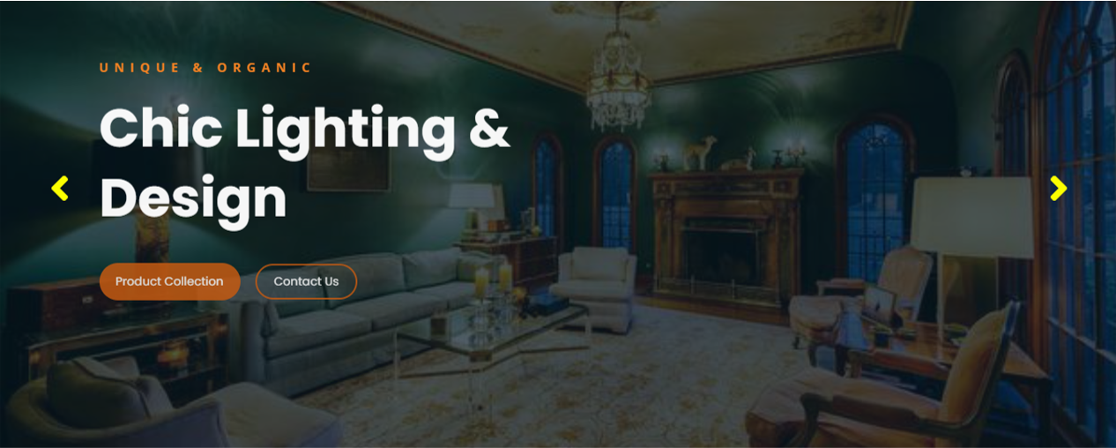
Home

This include info about , products Collection and the Contact Us to shows you the different categories which you like most of them.

About
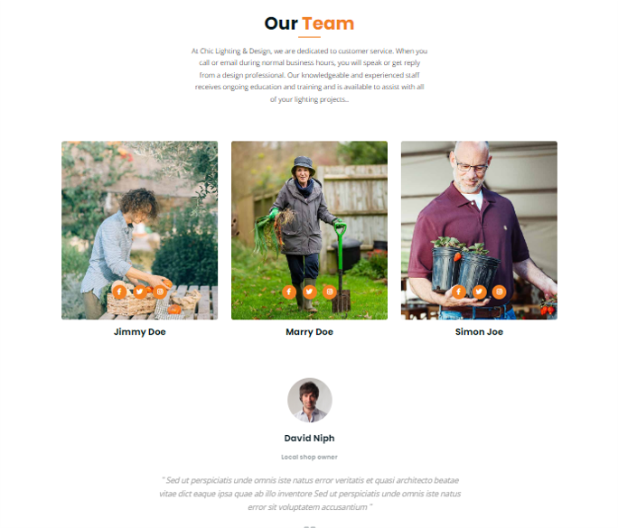

This section provides you the info about our Chic Lighting & Design. I use images different peoples, their names and their profile links , expertise and their experience.


Services

Services section provides you the info about our services . I use icon of different services and which helps you to know about the services ..

Categories
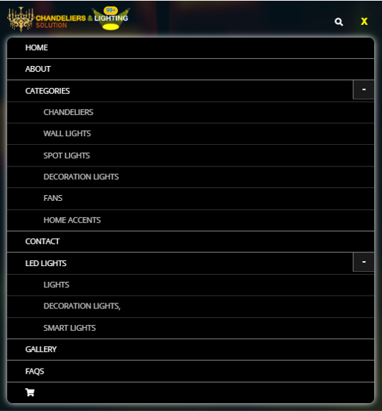

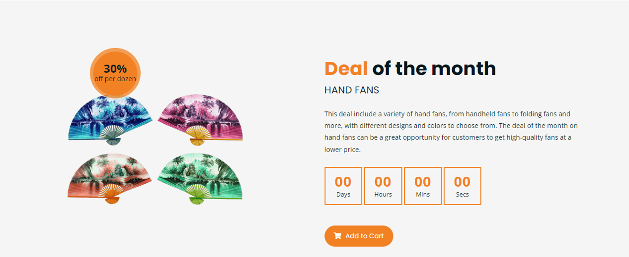
Our Discounts Deals
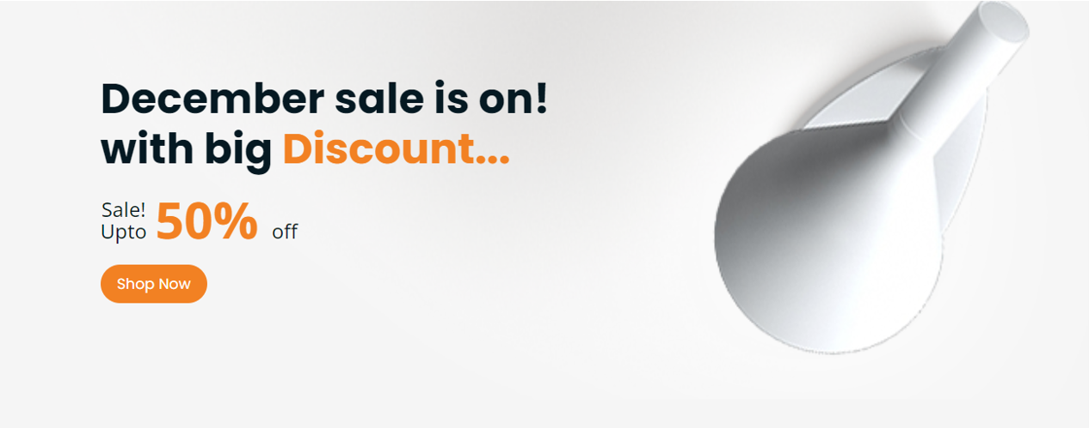

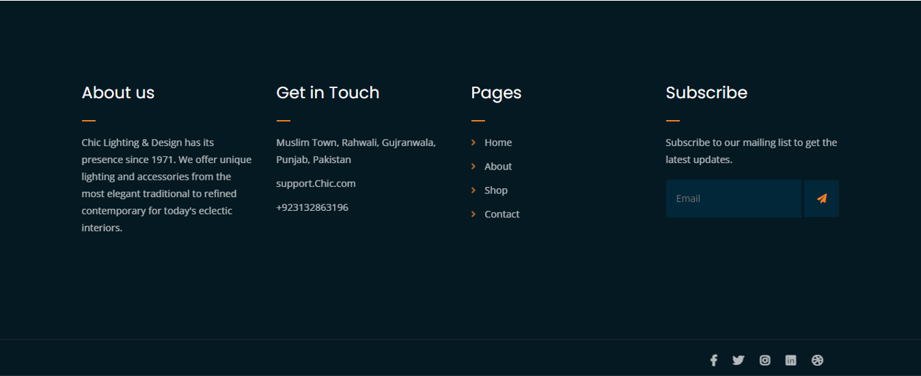
Contact and footer section

This footer gives you the information about the useful information about the website and provides you the correct address of our clinic. In the footer section we also provide links of our sections from where by clicking on any link you can easily go to your desired section.
We also provide a subscribe button for you guys if you really like our website.

